RESOLUTION NO.__________

RE: CERTIFICATE OF APPROPRIATENESS UNDER THE
PROVISIONS OF THE ACT OF THE PENNSYLVANIA
LEGISLATURE 1961, JUNE 13, P.L. 282 (53
SECTION 8004) AND BETHLEHEM ORDINANCE NO.
3952 AS AMENDED.

WHEREAS, it is proposed to renovate replace the siding at 410 E Fourth St.

NOW, THEREFORE, BE IT RESOLVED by the Council of the City of Bethlehem that a Certificate of Appropriateness is hereby granted for the work.

Sponsored by: (s)

(s)

ADOPTED BY COUNCIL THIS DAY OF

(s)
President of Council

ATTEST:

(s)
City Clerk

HISTORIC CONSERVATION COMMISSION

CASE # 526 – It is proposed to replace the siding at 410 E Fourth St.
OWNER/APPLICANT: KCK Realty, LLC / Ken Holland

The Commission upon motion by Mr. Roeder seconded by Mr. Cornish adopted the proposal that City Council issue a Certificate of Appropriateness for the proposed work described herein:

- The proposal to replace the siding at 410 E Fourth St. was presented by Ken and Keith Holland.

- The existing faux brick siding will be removed.

- If the existing historic siding and trim are in repairable condition, they will be scraped, prepped, and painted.

- If no siding is underneath existing, or the historic siding in very poor condition, 4”, prefinished, fiber cement siding will be installed.

- The proposed motion was unanimously approved.

CU: cu
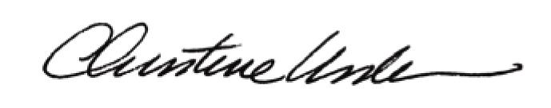

By:

Date of Meeting: November 17, 2014 Title: Historic Officer

